CMPS310

Project Milestone 2 – Group 02

Instructor: Ms. Alaa Hussien

Theory Section No: L02

Lab Section No: B01

Submission date: 23rd November 2024

Effort distribution

Maher Alwajih – 202210812 – L02 – Effort: 25%

Abdelrahman Abushahba – 202209706 – L02 – Effort: 25%

Sidi Chaikh – 202104008 – L02 – Effort: 25%

Omar Aboelrous – 202008853 – L02 – Effort: 25%

**Declaration**

We hereby certify that no part of this project or product has been copied from any other student’s work or from any other sources except where due acknowledgment is made in the project. No part of this project/product has been written/produced for us by any other persons.

DSD 1:

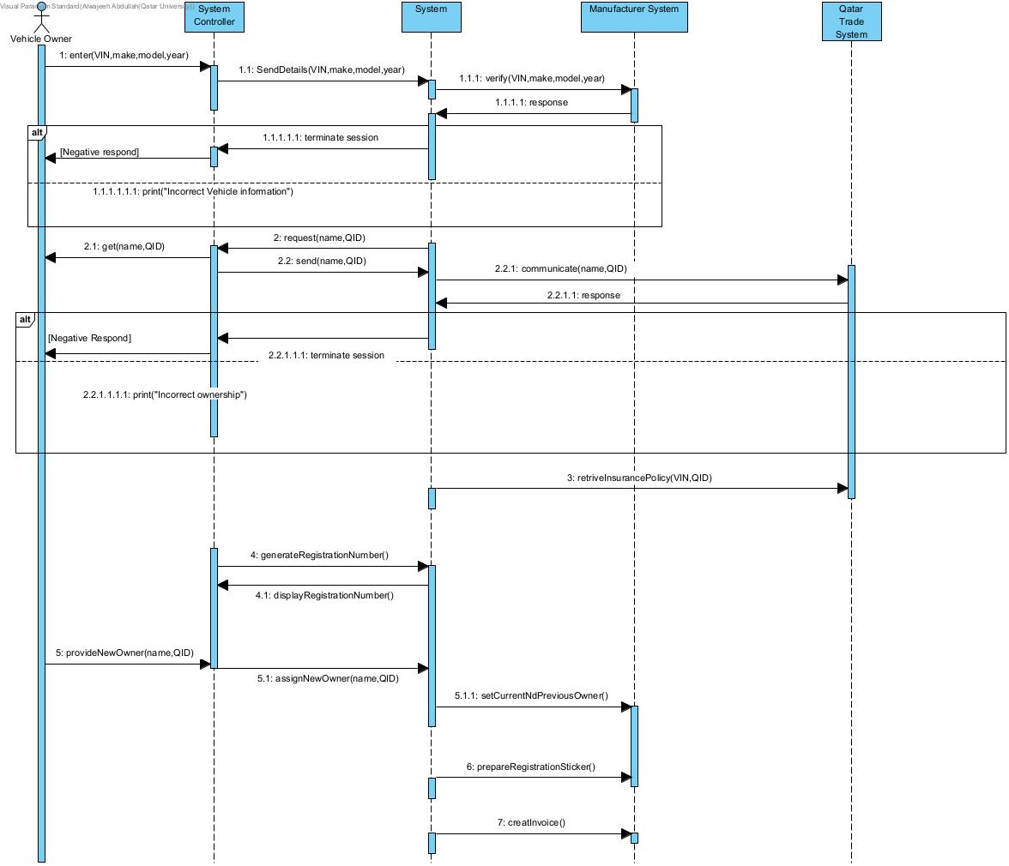

**Use-Case specification (For firsr daigram)**

|  |  |  |
| --- | --- | --- |
| **Use case Id: 01** | **Transfer Unregistered Vehicle** | |
| **Brief Description** | **This use case begins when the owner of a vehicle that is not registered wants to transfer the ownership to a new owner** | |
| **Primary actors** | **Vehicle Owner, Manufacturer System, Qatar Trade Services** | |
| **Trigger(s)** | **Vehicle owner enters the VIN and details of the unregistered car to transfer it to another owner** | |
| **Preconditions:**  **1. Registration does not exist** | | |
| **Post-conditions:**   1. **The vehicle was registered** 2. **The ownership was changed** 3. **A new registration sticker was created** 4. **An invoice was created**  |  | | --- | |  | | | |
| **Normal Scenario** | | |
| **Actor Action** | | **System Response** |
| **1. Vehicle owner enters the VIN and vehicle details (make, model, year).** | | **2. provide VIN and vehicle details to manufacturer system to verify** |
|  | | **3. request owner name and QID (see 3.a)** |
|  | | **4. Communicate with Qatar Trade Service providing name and QID** |
|  | | **5. retrieve insurance policy for vehicle(see 5.a)** |
|  | | **6.Generate a new registration number and assign it to the vehicle and display it** |
| **7.Vehicle owner provides details of the new owner** | | **8.Assign details of new owner to vehicle** |
|  | | **9.Set current and previous owner** |
|  | | **10.Prepare registration sticker** |
|  | | **11.Create invoice** |
| **)Alternative flows:**  **3.a. if the manufacturer response is negative, , terminates the session with the message “Incorrect Vehicle information”**  **5.a.if QTS response is negative, terminates the session with the message “incorrect ownership”** | | |
|  | | |

**DSD 2:**

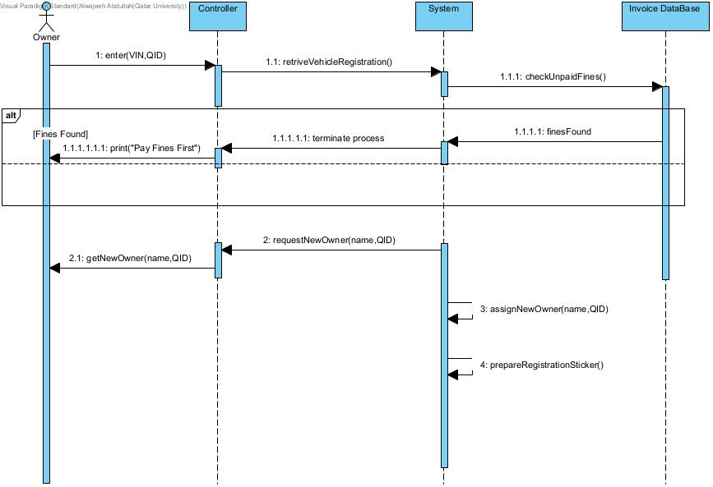

**Use-Case specification (For second daigram)**

|  |  |  |
| --- | --- | --- |
| **Use case Id: 02** | **Transfer Registered Vehicle Ownership** | |
| **Brief Description** | **The current owner transfers the ownership of a registered vehicle to a new owner. The system verifies the vehicle and checks for any unpaid fines or invoices before completing the transfer** | |
| **Primary actors** | **Current Owner** | |
| **Trigger(s)** | **The current owner initiates a request to transfer ownership of a registered vehicle.** | |
| **Preconditions:**  **1. The current owner has a registered vehicle.** | | |
| **Post-conditions:**  **Ownership of the vehicle is transferred to the new owner, and a new registration sticker is created** | | |
| **Normal Scenario** | | |
| **Actor Action** | | **System Response** |
| **1. Current owner enters the VIN and their QID.** | | |  | | --- | | **2. System retrieves the vehicle's registration details.(2.a)** |  |  | | --- | |  | |
|  | | **3. System checks for unpaid fines or invoices.(3.a)** |
|  | | **4. If no unpaid fines exist, system prompts for new owner's details.** |
|  | | **5. System assigns the vehicle to the new owner and generates a new registration sticker.** |
| **Alternative flows:**  **3.a. If unpaid fines or invoices exist, the system displays "Pay the bills first" and terminates the process** | | |
| **2.a. If vehicle details do not match, the system displays "Incorrect Information" and terminates the session** | | |

**Class Diagram:**

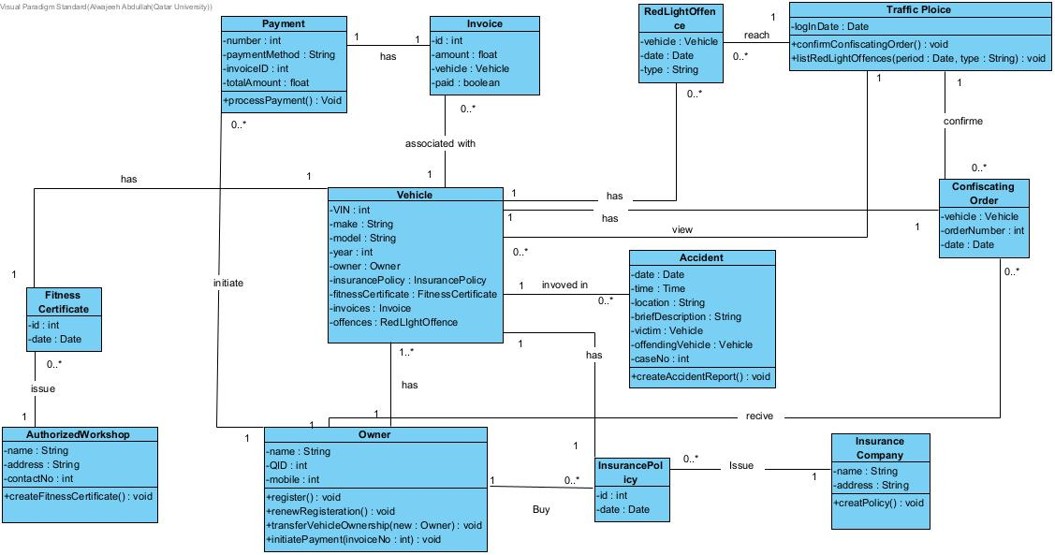

**Constraints**

1. Technical Constraints
2. The system must run as a plug-in for the existing registration system, which uses the Oracle database for data management.
3. The implementation must be developed using Java and C, as the staff are trained in these technologies.
4. The system must support a maximum of 20 new servers, as allocated by the budget.
5. It must operate with a team of 10 technical staff, which is the limit for new personnel hiring.
6. Core data regarding vehicles and ownership must be segregated from high-level user interfaces to protect sensitive information.
7. Operational Constraints
8. The system must initially handle up to 10 million vehicles and scale to 30 million vehicles within 10 years.
9. Vehicle ownership and registration data must remain confidential and protected from exposure to any unauthorized or general user-level functions.
10. The first version of the system must be delivered within three months, with the entire system expected to be operational within 12 months.
11. Budgetary Constraints
12. The system must be designed within the financial limitations of the department, supporting only 20 servers and 10 additional technical staff.
13. Legal and Regulatory Constraints
14. The system must adhere to Qatar’s vehicle registration and insurance regulations.
15. Sensitive vehicle ownership data must comply with Qatar’s data protection laws and should only be accessible by authorized personnel.
16. Insurance and fitness certificate requirements must follow the standard legal processes outlined by Qatar’s authorities.

**Quality Requirements (Non-Functional Requirements)**

1. Scalability

* Requirement: The system must scale to accommodate up to 30 million vehicles within 10 years without significant performance degradation.
* Scenario: By year 2034, the system should handle up to 50,000 vehicle transactions per day during peak periods.

1. Security

* Requirement: The system must encrypt all ownership and registration data to protect against unauthorized access or breaches.
* Scenario: Any unauthorized access attempt should trigger an alert and log the activity for review by administrators.

1. Portability

* Requirement: The system must function seamlessly on various platforms, including mobile phones, tablets, and desktops.
* Scenario: A vehicle owner should be able to transfer vehicle ownership using the system from a mobile device.

1. Performance

* Requirement: Core operations such as vehicle registration and accident reporting must respond within 2 seconds under normal load conditions.
* Scenario: During high traffic periods, the system should process up to 10,000 simultaneous transactions without noticeable delays.

1. Maintainability

* Requirement: The system should allow for upgrades, such as the addition or removal of features, without affecting existing functionality.
* Scenario: Adding a new feature for vehicle inspection results should not require changes to the ownership transfer module.

1. Reliability

* Requirement: The system must recover from failures within 30 minutes to ensure minimal disruption.
* Scenario: If a server crashes during peak hours, the system should automatically failover to a backup and resume normal operations.

1. Usability

* Requirement: The system must provide an intuitive and professional user interface for all user types (vehicle owners, insurance companies, workshops).
* Scenario: A first-time user should be able to navigate the system and complete a vehicle registration transfer without external guidance.

1. Extensibility

* Requirement: The system must support the integration of new features in the future without significant redesigns.
* Scenario: A new module for environmental impact reporting can be added without requiring changes to the database schema.

**NFRs Testing**

1. Testing for Portability:

System running on MacOS:

System Running on Windows 11:

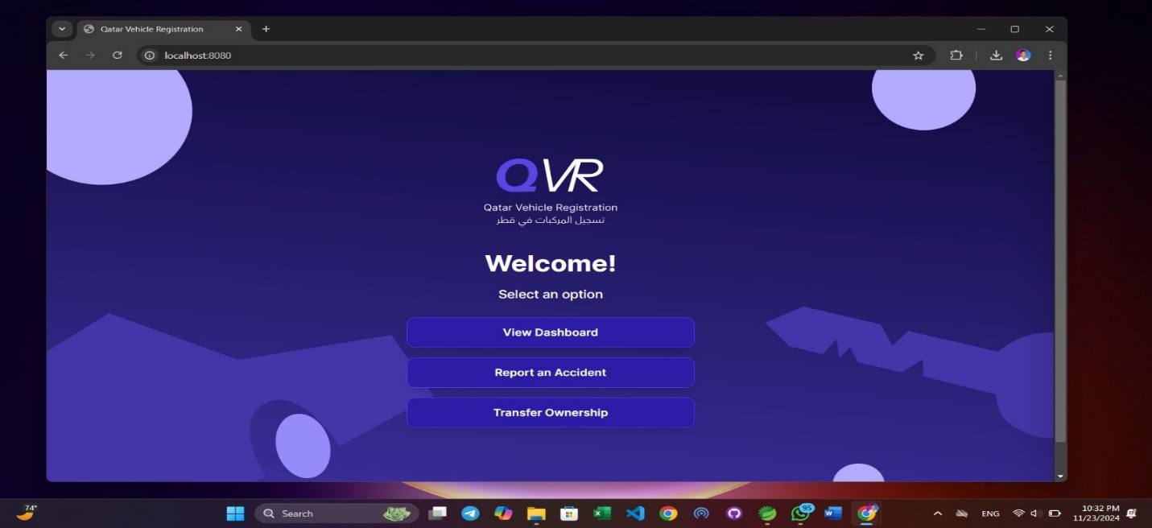

1. Testing for Usability:

We created a user flow to guide users into using the system smoothly and efficiently, then we had some random users use the system and fill a survey evaluating their experience using our system. Here is the user guide, followed by the results of the survey.

After running the system file: you’ll get this screen:

To open the dashboard, choose the first option:

To report an accident, choose the second option and enter the details:

To transfer ownership, choose the third option and enter the details:

Our survey had six questions and we received 18 responses; here are the results:

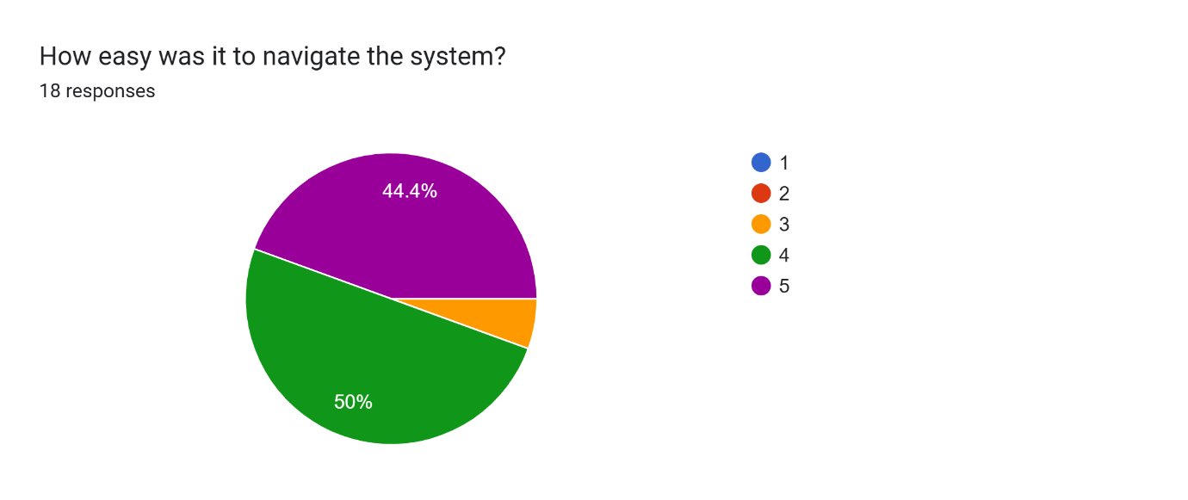

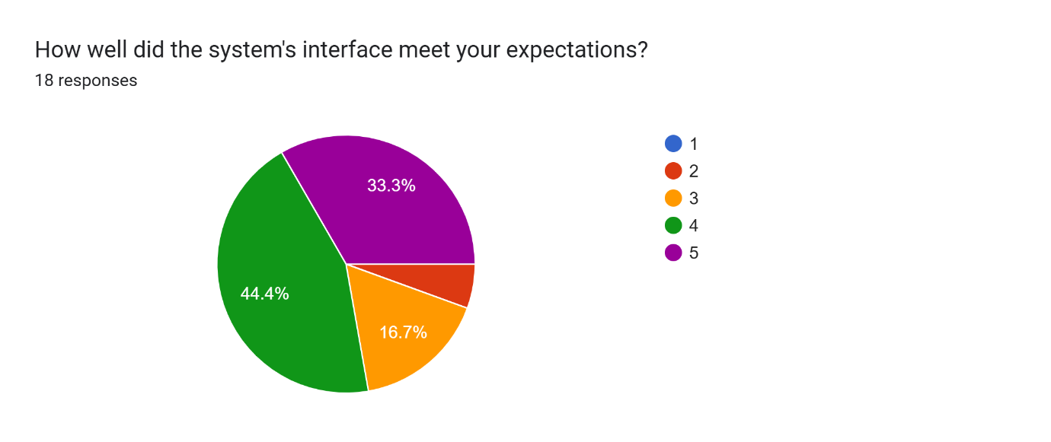

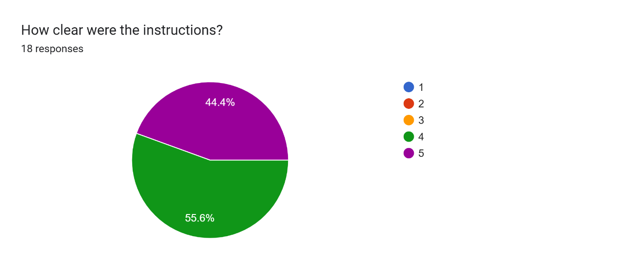

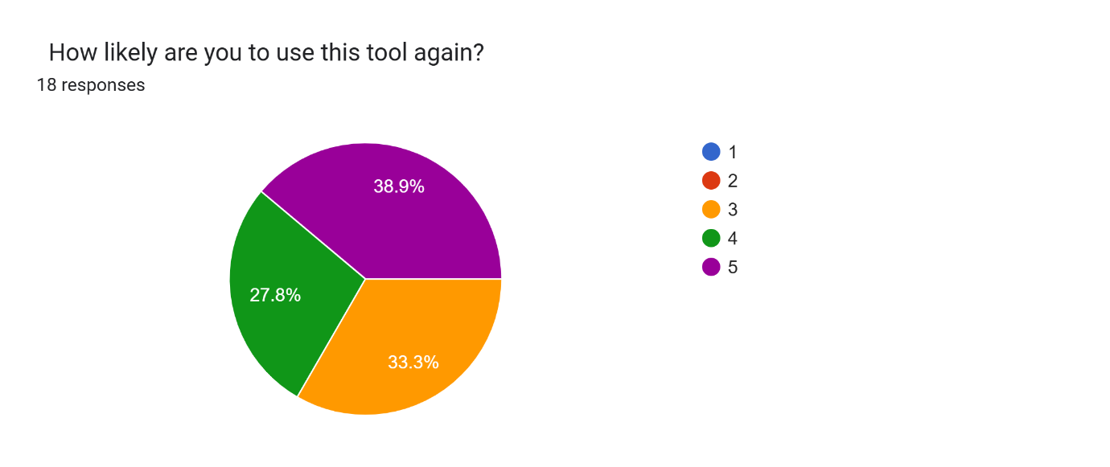

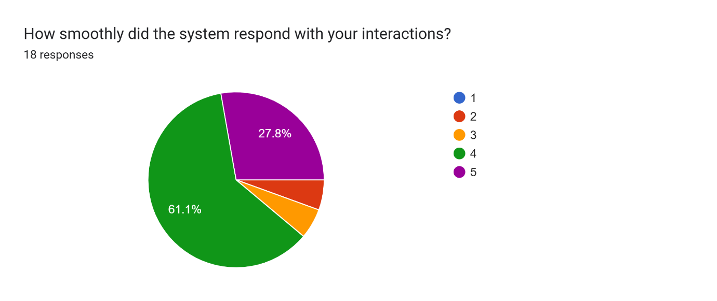

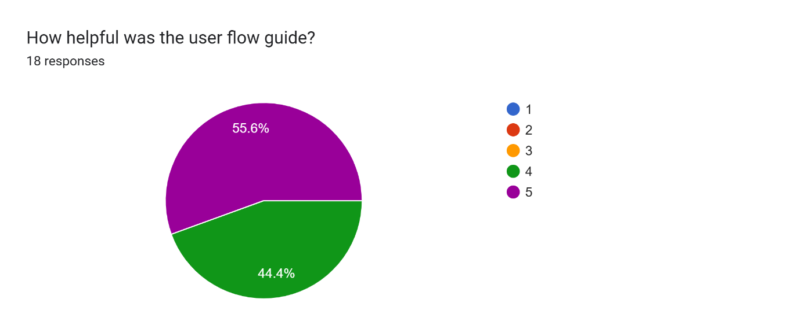

1. Testing for Reliability:

Our system handles incorrect inputs without crashing, here are two examples of that when entering wrong VIN when reporting an accident:

and entering incorrect details when transferring vehicle ownership:

